**Variables & Comments in C++ in Hindi | C++ Tutorials for Beginners #3**

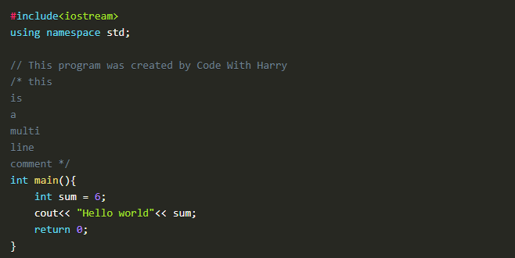

***Figure 1: C++ Sample Code***

**Variables in C++**

Variables are containers to store our data. To make it easy to understand, I will give a scenario: to store water, we use bottles, and to store sugar, we use a box. In this scenario, the bottle and box are containers that are storing water and sugar; the same is the case with variables; they are the containers for data types. As there are many types of data types, for example, "**int"** is used for integers, the "**float"** is used for floating-point numbers, "**char"** is used for character, and many more data types are available, we will discuss them in upcoming lectures. The main point here is that these variables store the values of these data types. Figure 1 shows an example of a variable. "**sum"** is taken as an integer variable, which will store a value 6, and writing sum after the "**cout"** statement will show us the value of "sum" on the output window.

**Comments in C++**

A comment is a human-readable text in the source code, which is ignored by the compiler. There are two ways to write comments.

**Single-Line Comments:** 1st way is to use" //" before a single line of text to make it unparsable by the compiler.

**Multi-Line Comments:** 2nd way is to use "/*" as the opening and "*/" as the closing of the comment. We then write text in between them. If we write text without this, the compiler will try to read the text and will end up giving an error.  Figure 1 shows examples of these comments.

**Code as described/written in the video**

#include<iostream>

using namespace std;

// This program was created by Code With Harry

/* this

is

a

multi

line

comment */

int main(){

int sum = 6;

cout<< "Hello world"<< sum;

return 0;

}

# Variable Scope & Data Types in C++ in Hindi | C++ Tutorials for Beginners #4

In this series of C++ tutorials, we will visualize the variable scope and data types in the C++ language in this lecture. In our last lesson, we discussed the variable's role and comments. In this C++ tutorial, we are going to cover two important concepts of C++:

* **Variable Scope**
* **Data Types**

Before explaining the concept of variable scope, I would like to clarify about variables a little more. Variable can be defined as a container to hold data. Variables are of different types, for example:

1. **Int**-> Int is used to store integer data e.g (-1, 2, 5,-9, 3, 100).
2. **Float**-> Float is used to store decimal numbers e.g (0.5, 1.05, 3.5, 10.5)
3. **Char**-> Char is used to store a single character e.g. ('a', 'b',' c', 'd')
4. **Boolean**-> Boolean is used to store "true" or "false."
5. **Double**-> Double is also used to store decimal numbers but has more precision than float, e.g. (10.5895758440339...)

Here is an example to understand variables: int sum = 34; means that sum is an integer variable that holds value '34' in memory.

**Syntax for Declaring Variables in C++**

1. Data_type Variable_name = Value;
2. Ex: int a=4; char letter = ‘p’;
3. Ex: int a=4, b=6;

#### Variable Scope

The scope of a variable is the region in the program where the existence of that variable is valid. For example, consider this analogy - if one person travels to another country illegally, we will not consider that country as its scope because he doesn't have the necessary documents to stay in that country.

Base on scope, variables can be classified into two types:

* **Local variables**
* **Global variables**

#### Local variables:

Local variables are declared inside the braces of any function and can be assessed only from there.

#### Global variables:

Global variables are declared outside any function and can be accessed from anywhere.

#### Data Types

Data types define the type of data that a variable can hold; for example, an integer variable can hold integer data, a character can hold character data, etc.

Data types in C++ are categorized into three groups:

* **Built-in**
* **User-defined**
* **Derived**

##### 1. Built-in Data Types in C++:

* Int
* Float
* Char
* Double
* Boolean

##### 2. User-Defined Data Types in C++:

* Struct
* Union
* Enum

Note: We will discuss the concepts of user-defined data types in another lecture. For now, understanding that these are user-defined data types is enough.

##### 3. Derived Data Types in C++:

* Array
* Pointer
* Function

Note: We will discuss the concept of derived data types in another lecture. For now, understanding that these are derived data types is enough.

#### Practical Explanation of Initializing Variables

We have discussed a lot in theory now; we will see the actual code and its working. The code for initializing variables is shown in Figure 1.

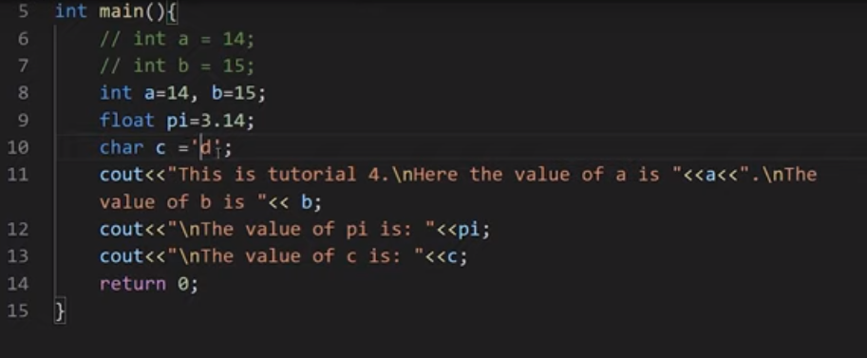

**Figure 1: initializing variables and printing their values**

In this code, we have initialized different types of variables and then printed them on screen. At line no 6 and 7, we initialized two integer variables a, and b, but they are commented out for compiler to ignore them. At line no 8, we have again initialized two integer variables a, and b, but this time they both are on the same line separated by a comma. The main thing to note here is that variables can be initialized on separate lines or in a single line. At line no 9, we have initialized a float variable pi and assigned a decimal value 3.14 to it. At line no 10, we have initialized a character variable c and assigned a character'd' to it.  At line no 11, we have printed the value of a, and b. The main thing to note here is that "**/n"** is used to print a new line. At line no 12, we have printed the value of pi. Similarly, in line no 13, the value of c is printed. The output for this program is shown in figure 2.

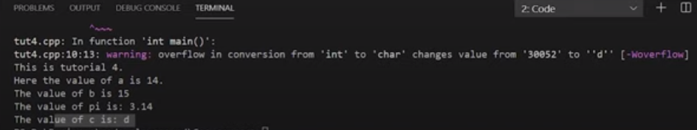

**Figure 2: Output of the Program**

#### Practical Explanation of Variables Scope

We have discussed the variable scope in theory now; we will see its actual code and working. So the code for variables scope is shown in figure 3.

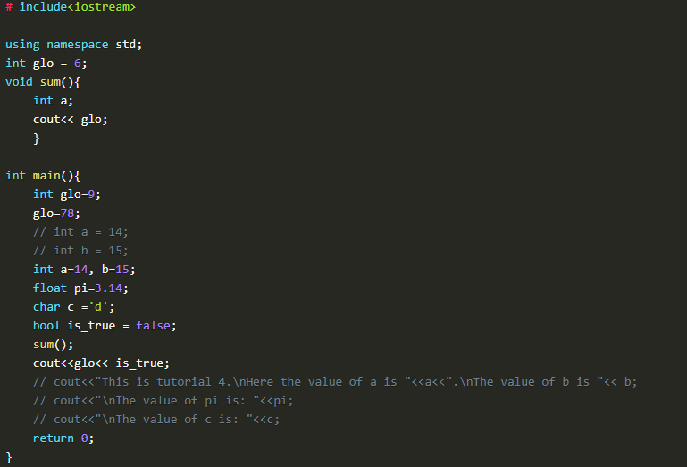

***Figure 3: Variables Scope Code***

In this piece of code, we have initialized two "glo" variables. 1st variable is outside the main function, and the 2nd variable is inside the main function. The value assigned to the "glo" variable outside the main function is 6, and the value assigned to the "glo" variable inside the main function is 9. One thing to note here is that in the main function, we have again assigned a value 78 to the variable "glo" which will update the previous value 9.

After initializing the "glo" variables, we had output the "glo" variables at two places in our program the 1st place is inside the main function, and the 2nd place is inside the sum function. **The main thing to note here is that:**

* When the "cout" will run inside the sum function, it will check for "glo" variable value inside the sum function. As we can see that there is no "log" variable initialized inside the sum function, it will check for the "glo" variable outside of the sum function scope, which we call a global scope. As we can see, that "glo" function is initialized in the global scope with the value 6, so the sum function will take that value.
* When the "cout" will run inside the main function, it will check for "glo" variable value inside the main function first, and as we can see that there is a "glo" variable initialized inside the main function scope which is a local scope, it will use that value.

The output of this program is shown in figure 4.

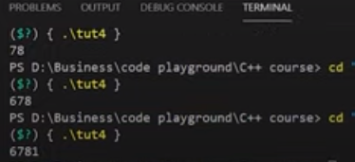

***Figure 4: Variable Scope Output***

As we can see that the output is "6781". The output 6 is from the cout of "glo" in sum function, the output 78 is from the cout of "glo" in the main function, and the output 1 is from the cout of "is_true" Boolean variable in the main function.

#### Rules to Declare Variables in C++

* Variable names in C++ language can range from 1 to 255
* Variable names must start with a letter of the alphabet or an underscore
* After the first letter, variable names can contain letters and numbers
* Variable names are case sensitive
* No spaces and special characters are allowed
* We cannot use reserved keywords as a variable name

#### Code as described/written in the video

# include<iostream>

using namespace std;

int glo = 6;

void sum(){

int a;

cout<< glo;

}

int main(){

int glo=9;

glo=78;

// int a = 14;

// int b = 15;

int a=14, b=15;

float pi=3.14;

char c ='d';

bool is_true = false;

sum();

cout<<glo<< is_true;

// cout<<"This is tutorial 4.\nHere the value of a is "<<a<<".\nThe value of b is "<< b;

// cout<<"\nThe value of pi is: "<<pi;

// cout<<"\nThe value of c is: "<<c;

return 0;

}